Sutton Municipal Center
4 Uxbridge Road
Sutton, MA. 01590
Telephone (508) 865-8724
Fax (508) 865-8721

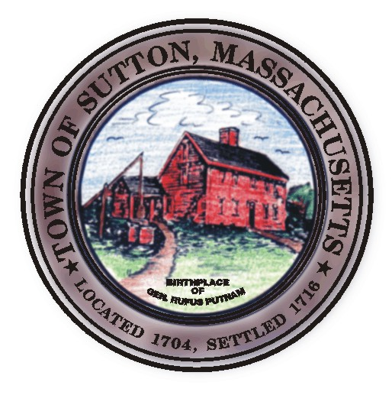
Dr. Steven Rice, Chairman,
John Silverberg, Vice Chairman
Diane Miller, Member
William Fredericks, Member
Kenneth Malo Jr., Member
James Malley, Health Agent
Cheryl Rawinski, Public Health Nurse
Christine Fant, Administrative Assistant

TOWN OF SUTTON

Board of Health Meeting Agenda

May 12, 2009

- Tobacco Regulations

- Approval of Minutes

- Old Business/New Business

Posted in Town Clerks Office

May 8, 2009

